SMMS: PRD, Technical Proposal and Workflow Document
Prepared for the HumanCentric Labs (HCL) Service Model Management System (SMMS) project. Derived from four client decks: HCL_SMMST_Introduction, HCL_SMMS_POC_v5, SMMM_1_0_Agent_and_design (5-5-26) and TiM_Presentation (5-14-26).

How to use this document
This single document combines three deliverables that are normally written separately:
- Part A: Product Requirements Document (PRD). What we are building, for whom, and why.
- Part B: Technical Proposal. How we propose to build it.
- Part C: Workflow Document. How the product and the engagement actually run, step by step.
Each part ends with a short checklist so you can reuse the structure for any project. Items marked [Source] come directly from the client decks. Items marked [Proposed] are my recommendations or placeholders that the client must confirm. Items marked [Open] are unresolved questions.
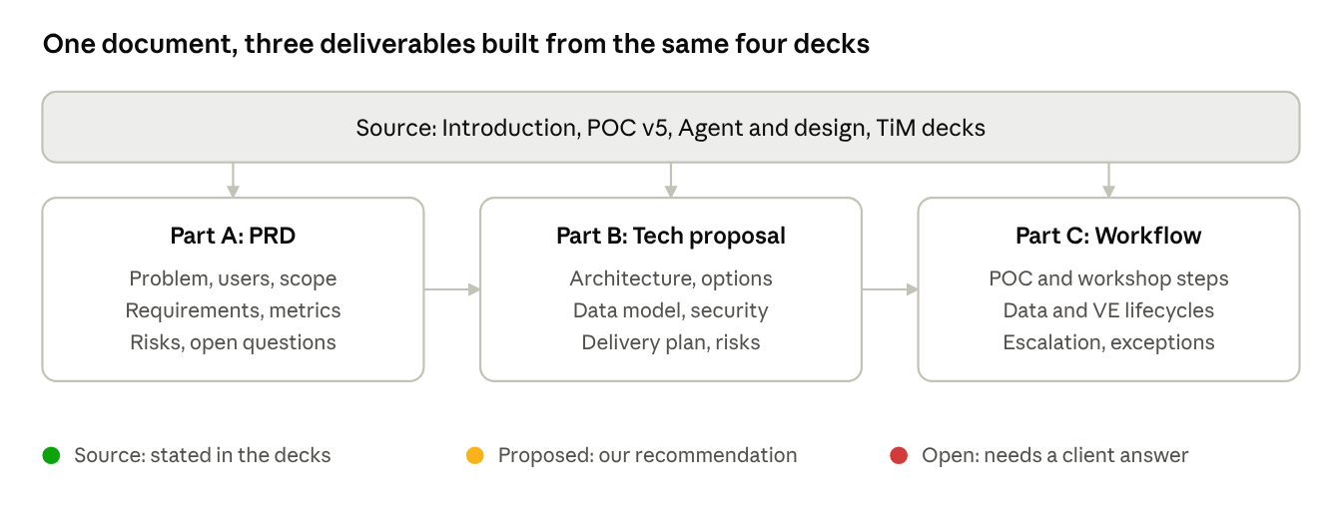
document map · 3 parts + tag key

Project at a glance
HCL argues that companies manage work through jobs, functions and departments, while customers only experience services. As AI changes how work is done, the management system must change too. SMMS manages the workforce by services, using Talent+AI™ (a human plus AI working as one unit) as the unit of work. Value is measured with ROTA™ (Return on Talent+AI Investment). The long-term goal is a Highly Adaptable Organization (HAO) with margin acceleration in 18 to 24 months. [Source]
The client materials describe three connected things:
- A framework and methodology: Service Profiles, %FTE, a 4-step process, and a 10-week POC.
- A platform: SMMS software that converts job data into services and tracks them.
- An AI agent layer: Talent+AI agents that negotiate Value Exchanges between suppliers and customers.

Part A: Product Requirements Document (PRD)

A1. How to prepare a PRD (the method)
A PRD answers: why, for whom, what, how will we know it works, and what is out of scope. Prepare it in this order:
- Write the problem and goals before any features.
- Name the users and their jobs-to-be-done.
- List functional requirements, each testable.
- Add non-functional requirements (security, performance, governance).
- Define success metrics.
- Record assumptions, risks, dependencies and open questions.

A2. Problem statement
Organizations are built around jobs and departments, which are optimized for internal control. Customers experience outcomes, so the way work is managed does not match how value is created. AI makes this gap larger because tasks are automated but nobody measures or reallocates the freed capacity. [Source]

A3. Vision and goals
- Vision: every role is expressed as measurable services, delivered by Talent+AI, continuously improved.
- Goal 1: convert job data into normalized service profiles at scale.
- Goal 2: reallocate freed capacity to higher-value services.
- Goal 3: measure return per service with ROTA.
- Goal 4: let agents manage supplier-customer service agreements (Value Exchange) with human oversight.
- Business goal: margin acceleration in 18 to 24 months. [Source]

A4. Users and personas
Persona | Needs | Main features used
Individual contributor (Talent) | See my services, %FTE and customers; improve my work | Service Profile, Talent+AI agent, improvement projects
Team lead / manager | Combine individual profiles into team services; assign projects | Team view, team projects, reviews
Executive sponsor | See value, ROTA and scale plan | Executive dashboard, ROTA, scaling strategy
HR / transformation team | Load job data, run workshops, govern | HRIS import, catalog admin, governance
Customer (internal or external) | Receive defined service quality | Value Exchange agreements
Management Agent (system actor) | Enforce rules, escalate | Rules engine, escalation
Personas other than the participants and executives named in the POC are [Proposed].

A5. Scope
In scope (version 1): service catalog, Service Profile with %FTE totalling 100%, current and future profiles, service attributes, self-assessment, project tracking, Talent+AI login agent, ROTA view, monthly and quarterly review support.
Phase 2 candidates: agent-to-agent Value Exchange automation, multi-service negotiation, external partner agents, tokenized SVM ledger.
Out of scope until clarified: fine-tuned proprietary model, blockchain ledger. [Proposed]

A6. Functional requirements
ID | Requirement | Priority | Source
FR-1 | Import job role data from HRIS and any existing service catalog | Must | Source
FR-2 | Use an LLM to decompose roles into candidate services | Must | Source
FR-3 | Normalize outputs to a common schema (service, customer, %FTE, attributes) | Must | Source
FR-4 | Human review and correction of generated services | Must | Source
FR-5 | Service Profile editor; %FTE must total 100% for current and future | Must | Source
FR-6 | Support internal customers (individual, team, group, function) and external customers | Must | Source
FR-7 | Self-assessment questionnaire feeding improvement opportunities | Should | Source
FR-8 | Create individual and team improvement projects with actions and outcomes | Must | Source
FR-9 | Add AI applications to current and future profiles | Should | Source
FR-10 | Prioritization view: business value vs AI suitability | Should | Source
FR-11 | ROTA calculation per service and enterprise average | Must | Source
FR-12 | Login agent showing service portfolio, VE status, comms drafting | Should | Source
FR-13 | Monthly review and quarterly assessment support | Should | Source
FR-14 | Value Exchange lifecycle with supplier and customer agents | Could | Source
FR-15 | Management Agent: rules, frequency monitoring, escalation to humans | Could | Source
FR-16 | Model-agnostic agent interface (swap LLM without UX change) | Must | Source
Priorities (Must, Should, Could) are [Proposed].

A7. Non-functional requirements
- Security and privacy: enterprise controls, encryption in transit and at rest, least-privilege access. [Source: governance slide]
- Quality: validated outputs, human-in-the-loop checks, continuous testing. [Source]
- Accountability: audit trails, clear ownership, traceability. [Source]
- Responsible AI: human oversight, transparency, bias detection. [Source]
- Cost: near-zero per-user LLM cost in version 1 (Option A). [Source]
- Performance, availability, data residency: [Open]. Not specified in the decks.

A8. Success metrics
- ROTA per service and enterprise average (deck example: 2.0x and 2.4x).
- Capacity reallocated (example: 18%).
- High-value services scaled (example: 7).
- Faster delivery 20 to 40%, capacity freed 15 to 30%, average ROTA 2 to 3x (HCL's typical-impact claims; vary by context).
- Business outcome: margin acceleration within 18 to 24 months.
Example figures in the decks are illustrative and should be replaced with baselines measured during the POC.
ROTA is calculated per service as:
ROTA = Net value created / Total Talent+AI investment

A9. Assumptions, risks, dependencies
Type | Item
Assumption | Job data is accessible from HRIS and is reasonably complete
Assumption | Participants can estimate %FTE honestly
Risk | LLM-generated services may be wrong, so human review is mandatory
Risk | Option A model has a limited capability ceiling
Risk | Employees may fear job loss, so change management is required
Dependency | Client HRIS access and SOW approval
Dependency | Answers to open questions (see A10)
The first assumption and the risk about employee concern are [Proposed].

A10. Open questions [Open]
- Service frequency: calendar cadence, trigger-based, or both?
- Agent autonomy: what can a supplier agent agree to independently?
- External partner protocol: same as internal or restricted?
- Multi-service awareness in negotiation: include now or later?
- SVM currency: show numerically now or in a future layer?
- Definition of Human Equivalence™ and how it converts AI to %FTE.

A11. PRD checklist
- Problem and goals written before features
- Personas named
- Every requirement testable and prioritized
- Metrics have baselines
- Out-of-scope list present
- Open questions owned by a named person

Part B: Technical Proposal

B1. How to prepare a technical proposal (the method)
A technical proposal answers: what architecture, which options were considered, why this one, what it costs and what could go wrong. Prepare it in this order: context, constraints, architecture, options with trade-offs, recommendation, data model, security, delivery plan, risks.

B2. Technical context and constraints
- Must work with any LLM ("Aligns to Any LLM"). [Source]
- Must keep humans in the feedback loop. [Source]
- Must protect HCL's intellectual property. [Source]
- A working prototype already exists, built on the Claude API, with a system prompt that encodes SMMS context at login. [Source]

B3. System overview
SMMS has four technical components:
- Data ingestion: HRIS, job role data, existing service catalog.
- Service engine: LLM process that decomposes jobs into services and a normalizer that standardizes output.
- Service catalog and application layer: Service Profiles, projects, ROTA, reviews.
- Agent layer: Talent+AI agents, Management Agent, Value Exchange.
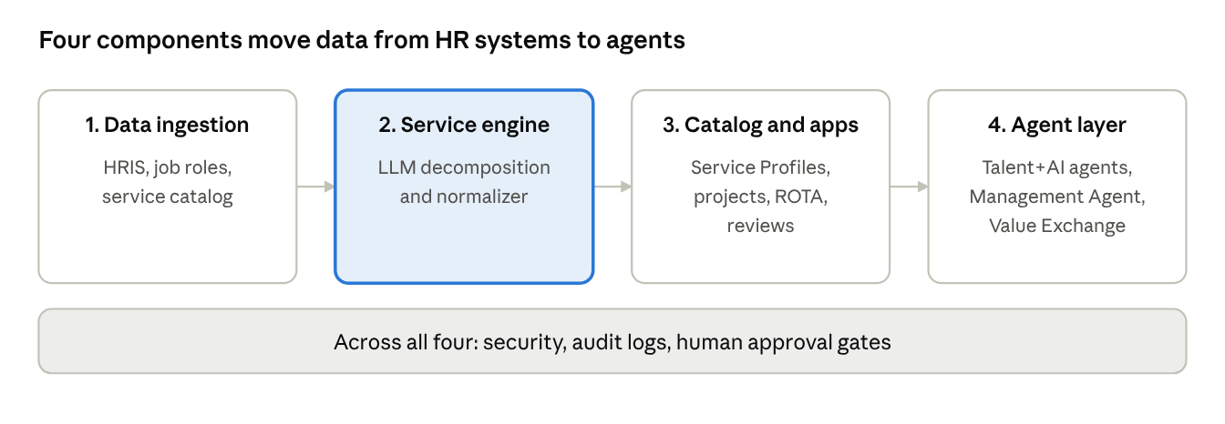
system components · 4 stages + shared controls

B4. Architecture: jobs to services pipeline
Data flow in order: Job data input, LLM process, normalize output, human feedback, service catalog (services, customers, %FTE), Workforce Agent. The Workforce Agent manages service changes, service value, the talent pool and resource supply and demand. [Source]
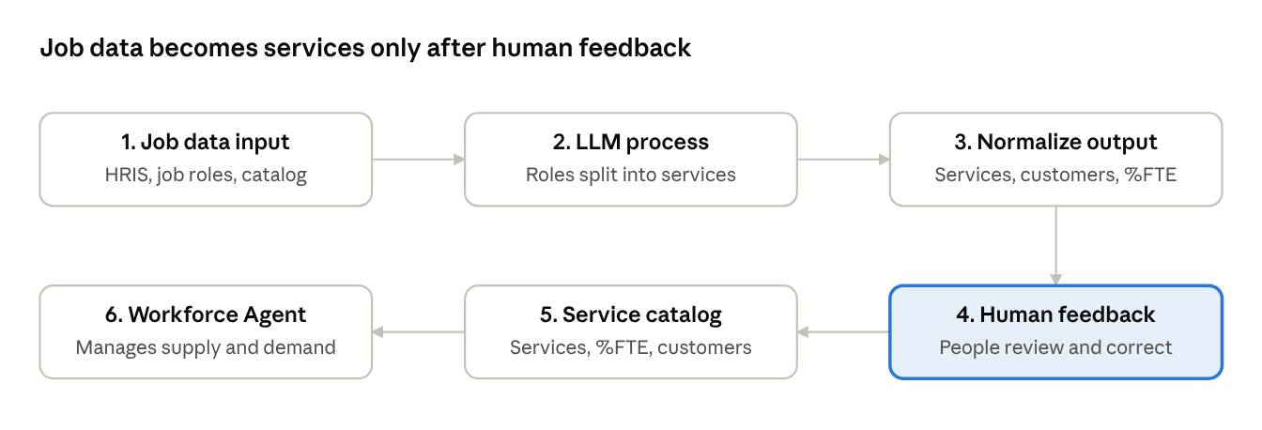
jobs to services pipeline · 6 steps
Read left to right on the top row, then right to left on the bottom row; the highlighted step is where people correct the LLM's output.

B5. Agent network architecture
A three-layer network [Source]:
- Individual layer: a Talent+AI node per person.
- Organization layer: team network with a Management Agent that routes and supervises.
- Ecosystem layer: external partners and partner agents.
App connectors link the nodes to enterprise systems (CRM, HRIS, finance). Agents communicate through a shared SMMS protocol.
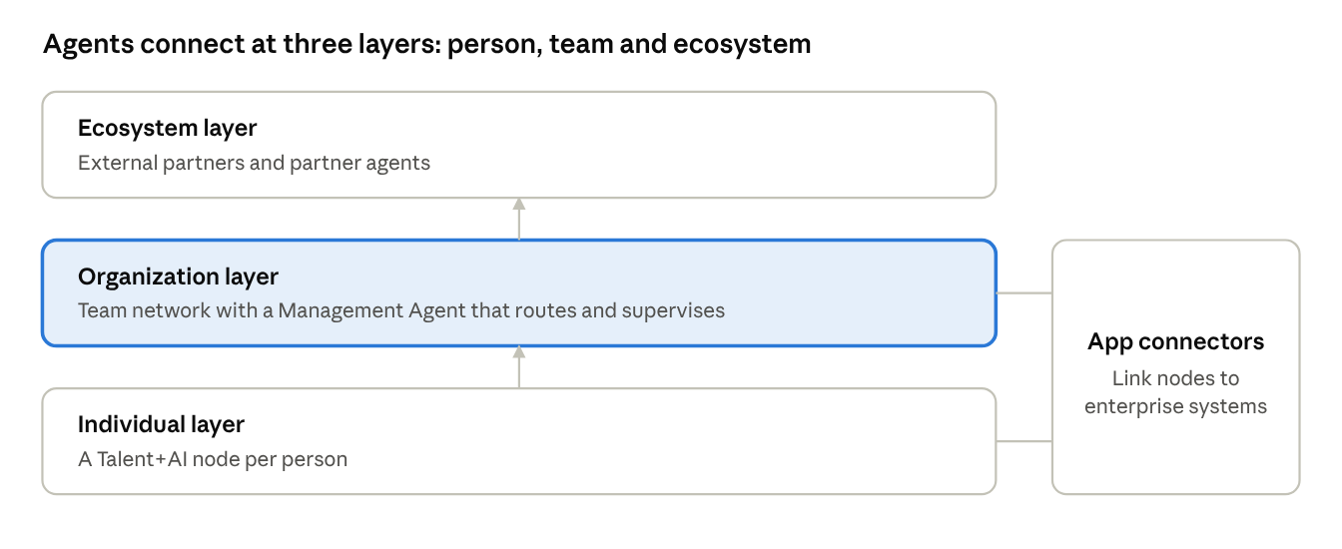
agent network · 3 layers + connectors
Each person's node talks up to the team network, which talks up to external partners; connectors tie the nodes to company systems.

B6. Option analysis: agent strategy
Option | Description | Pros | Cons
A: Embedded lightweight | Open-source LLM bundled into SMMS login | Near-zero per-user cost, full IP control, fast | Capability ceiling, maintenance burden
B: Federated multi-LLM | Router: local model for simple, licensed for complex | Best capability, cost-controlled, upgradable | Vendor dependence, API costs scale
C: HCL fine-tuned | Proprietary model trained on SMMS domain | Deepest moat, strongest IP, native fluency | 6 to 18 months, highest upfront cost
Recommendation [Source]: start with A, build the SMMS protocol so B and C remain compatible, and keep the agent interface model-agnostic from day one.

B7. Option analysis: Value Exchange design
Option | Description | Best for
1: Sequential state machine | One finite state machine per service-customer pair | Initial build and testing
2: Event-driven multi-agent | Independent VE process per pair, shared message bus, Management Agent with rules engine | Production, full value-chain awareness
3: Value chain ledger | Each agreement tokenized, auditable transactions | Long-term ecosystem scale
Recommendation [Source]: build Option 2 for production, start testing with Option 1, add the ledger as Phase 2.

B8. Data model (proposed)
The decks list required attributes; the entity layout below is [Proposed].
Entity | Key fields
Person / Talent | id, role, team, HRIS reference
Service | id, name, description, importance, quality, SVM
ServiceAllocation | person, service, customer, %FTE, version (current / 1-month / 3-month)
Customer | id, type (individual, team, group, function, external)
Project | id, owner, type (individual / team), actions, outcomes, status
ValueExchange | supplier, customer, service, state, frequency rule
Rule | frequency, escalation, negotiation limits
ROTAResult | service, value components, investment components, period
Constraint: %FTE of all ServiceAllocation rows per person and version must equal 100%.

B9. VE state machine
States [Source]: Active, Change Request, Negotiating, Defining, Delivering, Acceptance. Rules decide whether a step resolves automatically or escalates to a human.

B10. Prototype
The existing prototype uses the Claude API, loads the user's service portfolio and an active VE negotiation into the system prompt, supports multi-turn history, and offers quick actions (My Services, VE Status, Draft Comms, Top Customers). The deck cites an older model identifier; confirm the current model before production. [Proposed]

B11. Security and governance
Five pillars [Source]: principled AI use, security and data privacy, quality and reliability, accountability and transparency, continuous improvement. Technical controls to specify: encryption, role-based access, audit logs, human approval gates for agent decisions, evaluation sets for LLM output.

B12. Delivery plan
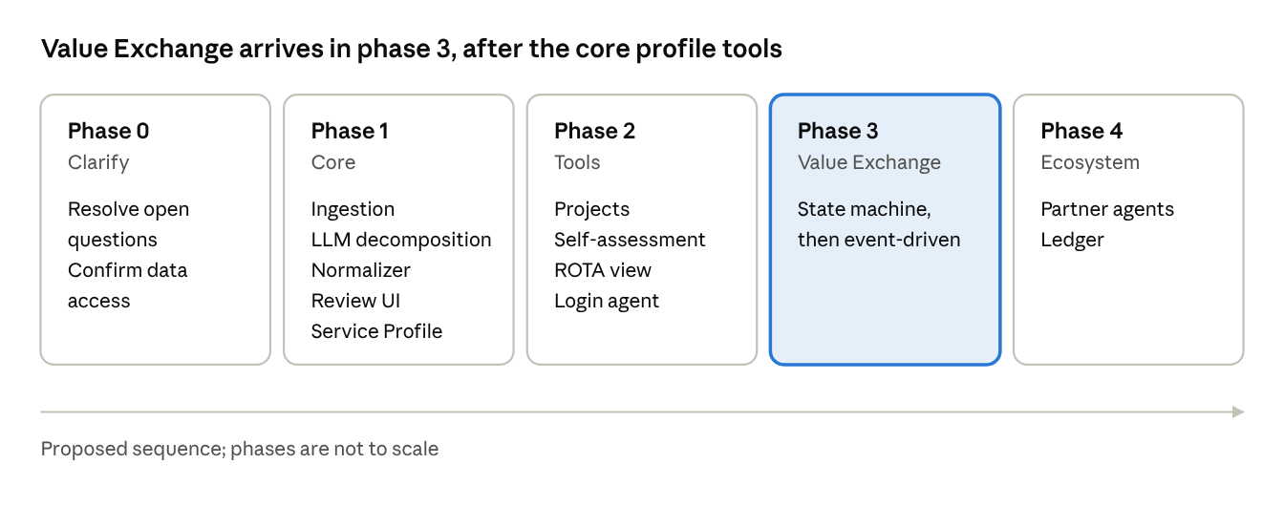
delivery roadmap · 5 phases [Proposed]
The phase breakdown is [Proposed]; the decks recommend starting as a Cowork or Claude Code project once questions are answered.

B13. Technical risks
- LLM decomposition accuracy: mitigate with human review and evaluation sets.
- Vendor lock-in: mitigate with the model-agnostic interface.
- Agent over-autonomy: mitigate with explicit escalation rules.
- Data sensitivity of HR data: mitigate with strict access control and minimization.

B14. Technical proposal checklist
- Constraints stated
- Architecture diagram included
- Each option compared on the same criteria
- Recommendation with reasons
- Data model and security covered
- Phased plan and risks

Part C: Workflow Document

C1. How to prepare a workflow document (the method)
A workflow document answers: who does what, in what order, with which inputs and outputs, and what happens when something goes wrong. Prepare it in this order: actors, triggers, steps, decision points, exceptions, handoffs, timing, outputs. Use one diagram per workflow and a table beside it.

C2. Actors
Participants (Talent), team leads, executives, HCL facilitators and coaches, Talent+AI agents, Management Agent, customers.

C3. Workflow 1: End-to-end engagement (10-week POC)
Weeks | Activity | Output
1 | Agree to POC | Commitment
2 | Define team and scope | Participant list, scope
3 | Agree SOW | Signed SOW
4 | Define and agree premises | Premises document
5 | Start process: Day 1 self-assessment and Exercise 1 | Service Profiles (current)
6 | Day 2: Exercise 2, group review, executive review | Future profiles, project drafts, scale strategy
7 to 10 | Individual projects (1 to 4 weeks), team projects (1 to 3 months) | Project results
After | Repeat transformation process; monthly and quarterly reviews | Lessons, margin contribution
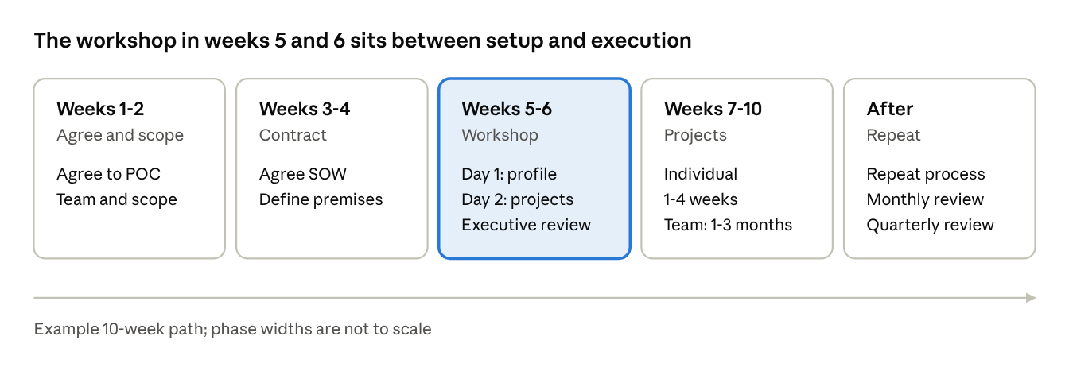
POC path · 5 phases
Setup takes four weeks, the two-day workshop produces the profiles and project drafts, and projects then run before the cycle repeats.

C4. Workflow 2: Day 1, create the Service Profile
- Optional self-assessment before the session (15 to 20 minutes).
- Introduction and assessment summary, then Exercise 1 (1 hour 40 minutes).
- Exercise 1, the 4-step process:
  - List projects and tasks per customer and service with %FTE, completing to 100%.
  - Define current and future transformation, also 100% FTE.
  - Move from individual to group services.
  - Add service attributes and begin the Framework.
- Group discussion in teams about assessment opportunities and the exercise.
- Break: individual review and revision, with coaching support as needed.

C5. Workflow 3: Day 2, profile and project improvements
- Q&A and review of self-assessment (about 1.5 hours including discussion).
- Exercise 2 (about 2 hours):
  - Framework features walkthrough.
  - Review and modify current and future profiles.
  - Add AI and other applications.
  - Define individual and team improvement projects, using the self-assessment as the source of opportunities; in groups of three, agree a team project.
  - Group discussion on process, projects and lessons.
- All-group review (1 hour): results, opportunities, next steps.
- Executive review (1 hour): POC process, lessons, strategy to scale (7-step process), execution team roles.

C6. Workflow 4: Jobs to services data pipeline
- HRIS and job data are loaded.
- The LLM proposes services per role.
- Output is normalized to the common schema.
- A person reviews and corrects; corrections feed back.
- Approved services enter the catalog.
- The Workforce Agent monitors supply and demand and suggests changes.
This is the same flow shown in section B4.

C7. Workflow 5: Value Exchange lifecycle
Phase | What happens | Who
Connect | Supplier and customer agents are linked | Agents
Signal | VE is active; periodic reviews; customer agent detects a gap (desired differs from existing attributes) | Customer agent
Negotiate | Supplier proposes solutions; customer evaluates against all attributes and the value chain; Management Agent applies rules | Both agents, Management Agent
Deliver | Agreement and project defined (outcomes, scope, timeline); human executes, agent tracks | Talent, agent
Accept | Customer approves (VE updated, back to Active) or rejects (back to negotiation) | Customer agent, human if escalated
Review | Scheduled reviews per frequency rules | Management Agent
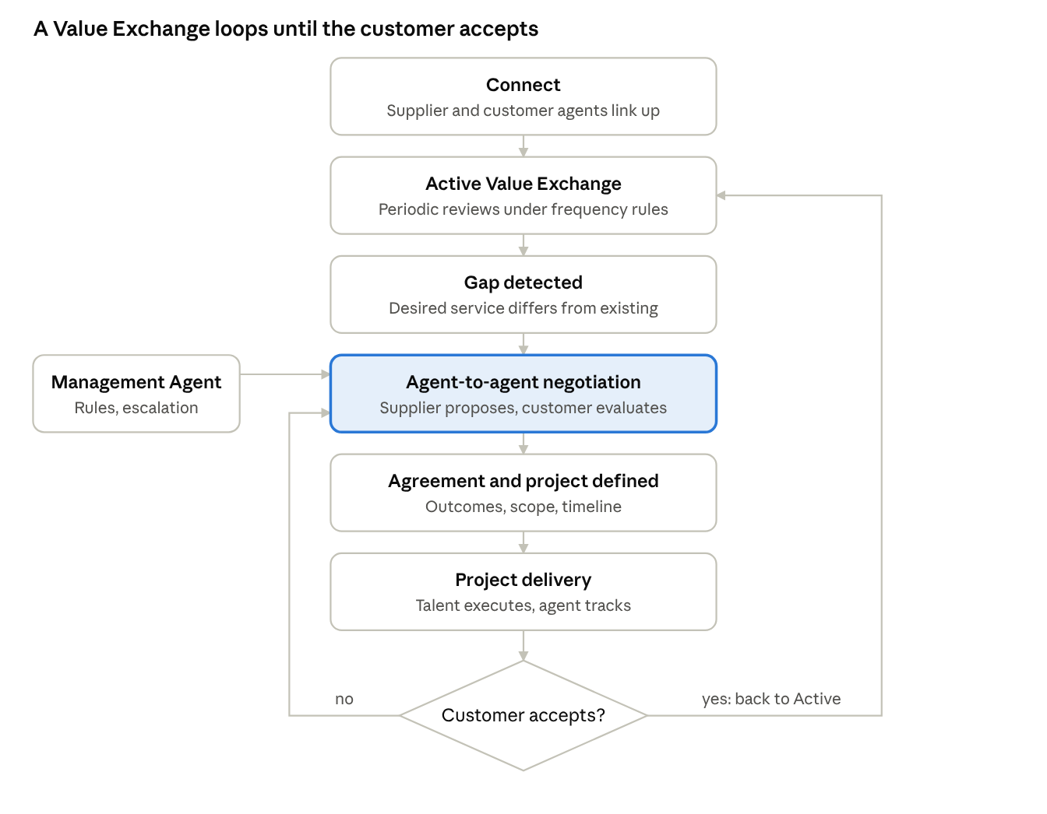
Value Exchange lifecycle · 1 decision, 2 loops
A rejection returns to negotiation, an acceptance returns the exchange to Active, and the Management Agent applies rules during negotiation.

C8. Workflow 6: Continuous improvement loop
Monthly review, then quarterly assessment, capturing lessons, focus and training needs, and margin contribution. Findings update service profiles and projects, and the transformation process repeats. The quarterly review is noted as a key milestone toward becoming a Highly Adaptable Organization.

C9. Escalation and exception handling [Proposed]
Situation | Action
%FTE does not total 100% | Block save, show remaining percentage
LLM output looks wrong | Reviewer edits; flag for evaluation set
Customer rejects delivery | Return to negotiation; escalate to human after repeated rejections
Request exceeds agent authority | Management Agent escalates to human Talent
The thresholds for escalation are [Open] until the client defines agent autonomy.

C10. Workflow document checklist
- Each workflow has a trigger and an owner
- Steps are numbered and time-boxed
- Decisions and exceptions are shown
- Inputs and outputs listed per step
- One diagram per workflow

Appendix: Glossary
Term | Meaning
Service | A named outcome delivered to a customer
%FTE | Share of a full-time person's capacity spent on a service; totals 100%
Service Profile | A person's or team's services with %FTE, customers and attributes
Talent+AI™ | A human plus AI as one working unit
ROTA™ | Net value created divided by total Talent+AI investment
HAO | Highly Adaptable Organization
SVM | Service Value Metric
VE | Value Exchange: live supplier-customer service agreement
Value Chain | Recursive chain of suppliers and customers
Management Agent | Supervisory agent that applies rules and escalates
Workforce Agent | Agent that converts job data into services and manages supply and demand
HRIS | Human resources information system
POC | Proof of Concept
SOW | Statement of Work

